Section A: Knowledge and Understanding
Part 1: Key Definitions

- What is a packet?
  - Packet is all data on a network which travels in small chunks

- What is the difference between a capture filter and a display filter in Wireshark?
  - Capture filter is a Wireshark filter you set before you start capture while display filter is a Wireshark filter applied after capture

- What is a SIEM, and why do organizations use one instead of reading logs on each server individually?
  - SIEM (Security Information and Event Management) is a centralized system that collects logs from all your devices like servers, firewalls, applications and it analyzes them together and organizations uses one instead of reading logs on each servers individually because it easier, faster and time saving

- What does ‘promiscuous mode’ mean when Wireshark captures traffic?
  - It means it captures and sends all traffic passing through the network segment directly to Wireshark for analysis

- What is a web proxy, and how does Burp Suite use this concept?
  - Web proxy is a server that sits between your browser and the internet.
  - Burp suite uses this concept as it intercept web browser traffic and let you edit it before it reaches the server.

Part 2: Protocol and Layer Matching
  - 1 - C
  - 2 - A
  - 3 - D
  - 4 - B
  - 5 - E
  - 6 - G
  - 7 - F
  - 8 - H
  - 9 - I
  - 10 - J

Part 3: True or False

- Wireshark can read the content of HTTPS traffic because it captures all packets.
  - False, Wireshark captures the packets, but cannot read the content of HTTPS traffic because it is encrypted

- A display filter in Wireshark permanently deletes packets that do not match the filter.
● False, a display filter only hides packets from the current view

- Event ID 4625 in Windows Security logs indicates a successful login.
  - False, event ID 4625 in Windows Security logs indicates a failed login attempt

- Burp Suite is a passive tool that only observes web traffic without modifying it.
  - False, burp suite intercept web browser traffic and let you edit it before it reaches the server.

- DNS queries are unencrypted by default, meaning Wireshark can see every domain name your computer looks up.
● True

- A SIEM collects logs from multiple devices into one centralized system.
● True

- Event ID 1102 means a new user account was created.
  - False, event ID 1102 means the Windows security audit log was cleared

- Wireshark and Burp Suite do the same thing.
  - False, Wireshark is a packet analyzer that captures raw network traffic across multiple protocols while Burp suite intercept web browser traffic and let you edit it before it reaches the server.

- Capturing network traffic on a public Wi-Fi network without permission is legal in Nigeria.
  - False, capturing network traffic on a public Wi-Fi network without permission is illegal in Nigeria

- TCP uses a three-way handshake (SYN, SYN-ACK, and ACK) to establish a connection.
● True

Part 4: Short Answer

- Name THREE pieces of information contained in every network packet.
  - The source address where the packet is coming from (IP)
● Destination address where the packet is going to (server IP)
● The payload: the actual data being sent.

- Explain why HTTP traffic is a security risk compared to HTTPS. What can an attacker see with Wireshark on HTTP that they cannot see on HTTPS?
  - HTTP traffic is a security risk compared to HTTPS because HTTP sends data in plaintext while HTTPS is encrypted and an attacker see full session data and credentials in
Plaintext with Wireshark on HTTP while an attacker can only see a cipher text with HTTPS

- What are TWO differences between Wireshark and Burp Suite?
  - Traffic can’t be modified on Wireshark, you can only view but traffic can be modified on Burp suite, it intercepts and modify
  - For position in Wireshark, it passively listens on the network but for Burp suite, it sits between your browser and the server.

Section B: Analysis and Critical Thinking
Scenario 1: The Morning Log Review

- What type of attack does the pattern of Event IDs 4625 (seven times) followed by 4624 suggest? Explain your reasoning.
  - It is a brute force attack because the log shows the attacker consecutively trying to break-in which was unsuccessful seven times before successful login

- After gaining access, the attacker performed THREE actions. List each action, state the Event ID that proves it, and explain WHY an attacker would do each one.
  - Event ID 4720 - New user account created - a new account to carry out the attack
  - Event ID 4732 User added to Administrators group - to gain full access and have administrative privileges
  - Event ID 4698 - Scheduled task created - allows the attacker to execute malware automatically at specific interval ensuring they can reconnect after system restart
● Event ID 1102 - Audit log was cleared - to hide evidence

- The attacker cleared the audit log (Event ID 1102). Does this mean all evidence is lost?
Explain what technology could have preserved the evidence, and how it works.
  - No, all evidence is not lost and SIEM.
  - SIEM works as a centralized system collecting all logs from all your devices like servers, firewalls, applications and it analyzes them together.

- The compromised account is called ‘svc_backup’. This is a service account, not a human user account. Why do attackers target service accounts specifically? Give TWO reasons.
  - Attackers target service accounts specifically because of privileged access and elevated permissions
  - Attackers target service accounts specifically because of less scrutiny where service accounts often bypass security control

Scenario 2: Suspicious Web Traffic

- The domain ‘login-safevault-verify.com’ is NOT the real SafeVault website. What type of attack does this traffic pattern suggest? Explain the evidence that supports your conclusion.
  - This type of attack is called phishing attack (credential harvesting via a fake lookalike domain). The clues were: fake domain name, HTTP instead of HTTPS, and redirect to the real site after capturing credentials.
- The traffic to the fake website uses HTTP (port 80), not HTTPS (port 443). Why is this significant? What can an analyst see in Wireshark because of this?
  - It is significant because data travels unencrypted and in plaintext
  - Because it is unencrypted, an analyst can read the exact contents of the HTTP

- After submitting credentials, the fake site redirects the user to the REAL SafeVault website. Why would an attacker design the attack this way? What does the user experience?
  - An attacker design the attack this way to maintain stealth and avoid raising suspicion
  - The user experiences a brief page reload before being dropped onto the authentic SafeVault website after filling details and clicking login.

- TWO employees (the POST at 14:22:05 and 14:23:00) submitted credentials to this fake site. As the security intern, describe THREE immediate actions you would recommend to your supervisor.
  - Force credential reset and revoke session
  - Block malicious indicators
  - Isolate and scan the affected endpoint

Scenario 3: The Wireshark Filter Challenge

- Show only DNS traffic.
  - Type dns in the display filter bar and press Enter.

- Show only traffic going TO the IP address 192.168.10.50.
  - Type ip.dst == 192.168.10.50 in the filter bar

- Show only HTTP POST requests (form submissions).
  - http.request.method == POST

- Show all traffic on port 443 (HTTPS connections).
  - tcp.port == 443

- Show all traffic EXCEPT ARP and DNS (to reduce background noise).
● !(arp || dns)

- Show only packets that contain the word ‘password’ anywhere in their content.
● The frame contains "password"` or `tcp contains "password"

- Show only SYN packets (TCP connection attempts, which could indicate a port scan).
● tcp.flags.syn == 1

Section C: Tool Comparison and Professional Judgement
Scenario 4: Choosing the Right Tool

- Task: A user reports that their computer is ‘sending data somewhere’ without their knowledge. You need to investigate what network connections the computer is making. Which tool and why?
  - The tool to use is Wireshark because it is a packet analyzer that captures and monitors network traffic in real time.

- Task: The web development team has deployed a new customer login page. Before it goes live, you need to test whether the login form is vulnerable to SQL injection or cross-site scripting (XSS). Which tool and why?
  - The tool to use is Burp suite because it is a specialized web application scanner and intercepting proxies designed to test web applications for vulnerabilities like SQL injection or cross-site scripting (XSS).

- Task: Three branch offices reported unusual activity last night. You need to check the login records across all 15 servers in the company simultaneously to see if the same attacker targeted multiple systems. Which tool and why?
  - The tool to use is SIEM because it collects logs from multiple devices into one centralized system

- Task: An employee’s laptop was stolen. You need to check whether anyone has tried to log in to the company network using that employee’s credentials since the laptop went missing. The company has 200 servers and 50 workstations. Which tool and why?
The tool to use is SIEM because it collects logs from multiple devices into one centralized system and searching/querying by the stolen laptop user's specific username across all 250 devices, the scale argument (checking each device individually is impossible), and alerting for future login attempts with those credentials.

- Task: A client’s website is loading slowly. You need to inspect exactly what HTTP requests the browser is making and check whether any requests are failing or redirecting incorrectly. Which tool and why?
The tool to use is Burp Suite because it intercepts HTTP requests, lets you inspect each one, and can identify failing or redirecting requests.

Section D: Practical Evidence via GitHub Task 1: Wireshark Packet Capture
  - Screenshot: Wireshark capturing live traffic
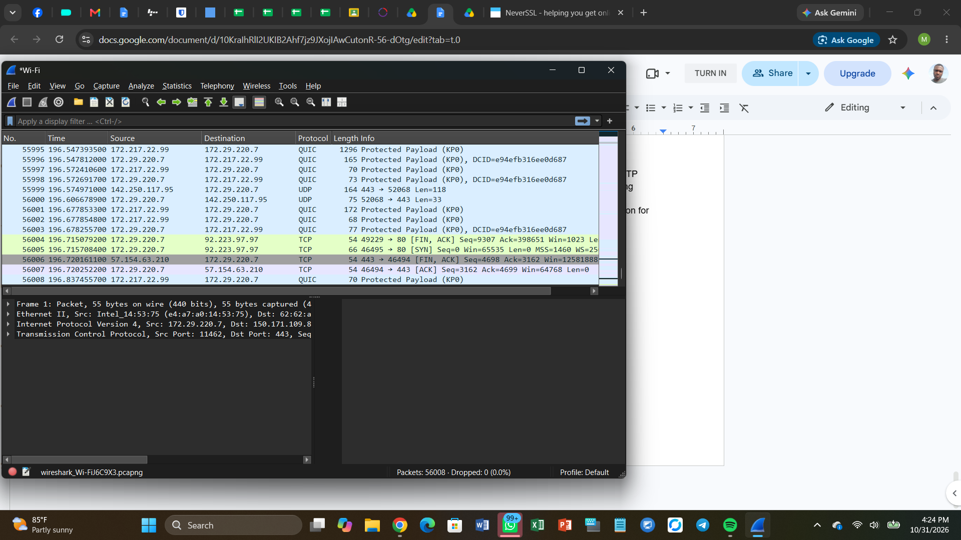

  - Screenshot: HTTP filter applied
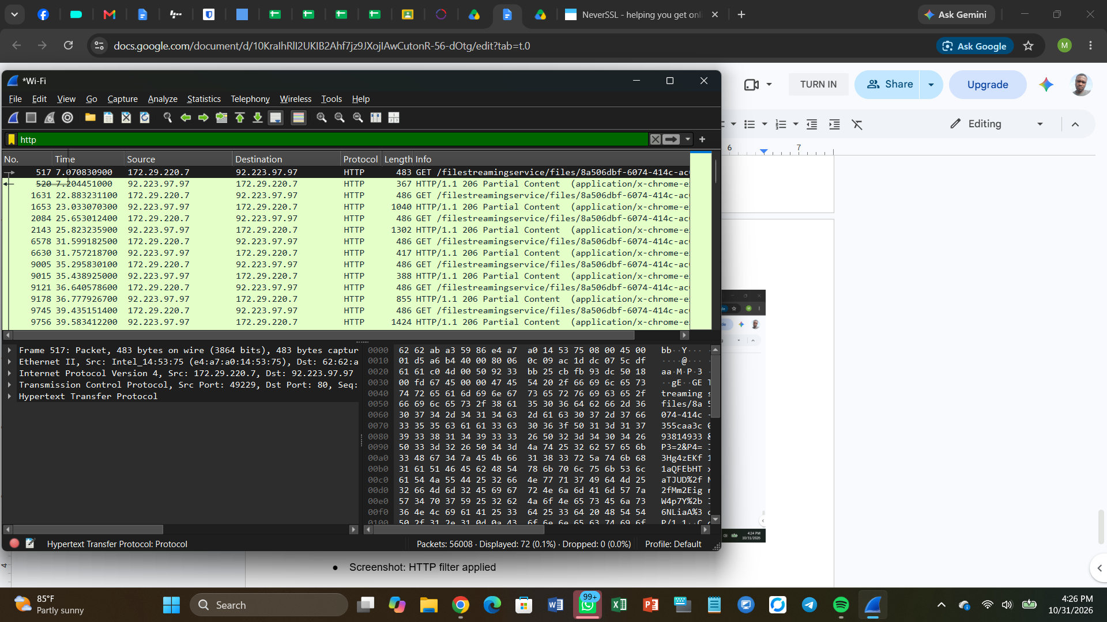

  - Screenshot: Follow TCP Stream
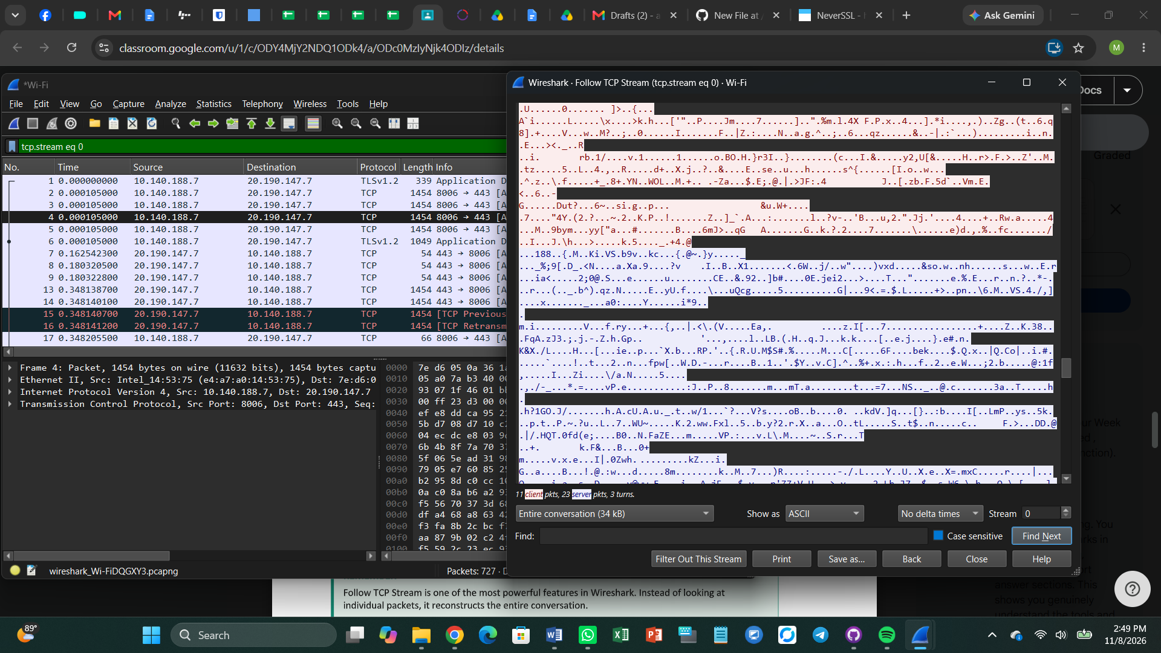

  - Screenshot: DNS filter showing domain lookups
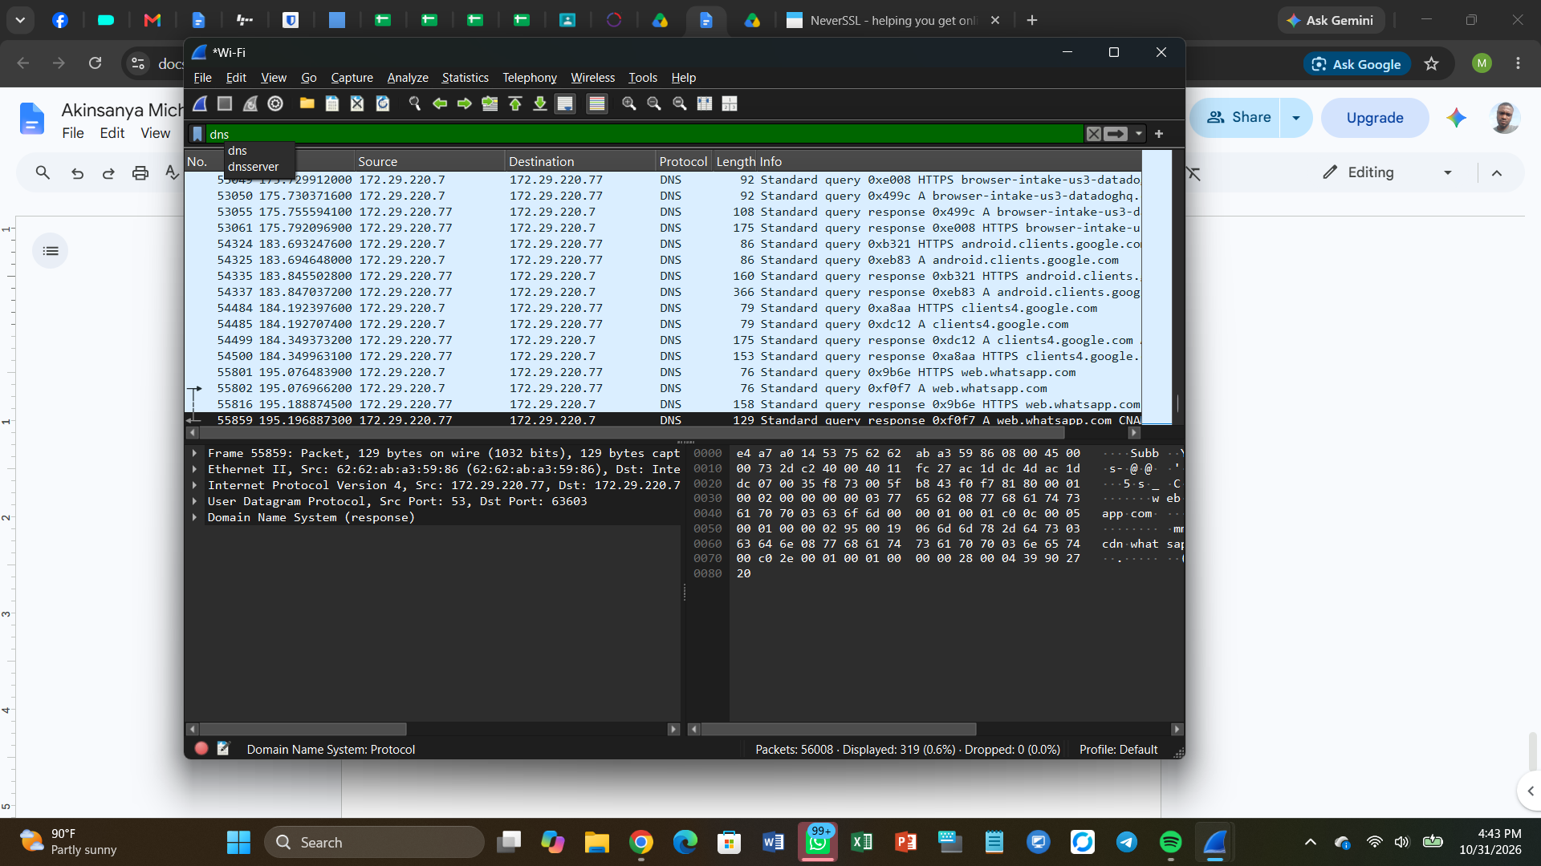

Task 2: Log Analysis Evidence
  - Screenshot: Event Viewer filtered by Event ID 4624
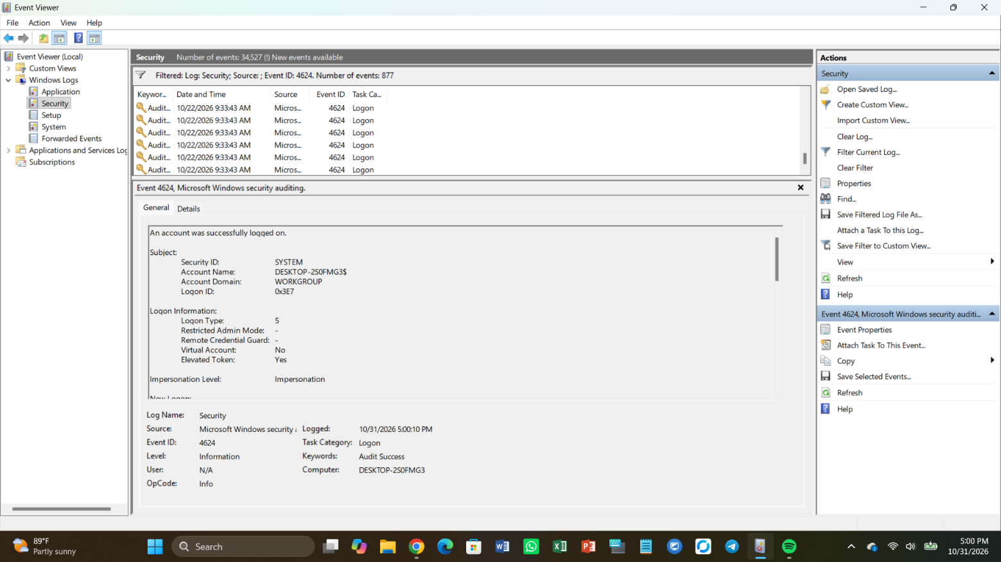

  - Screenshot: Event Viewer filtered by Event ID 4625 (if any exist)
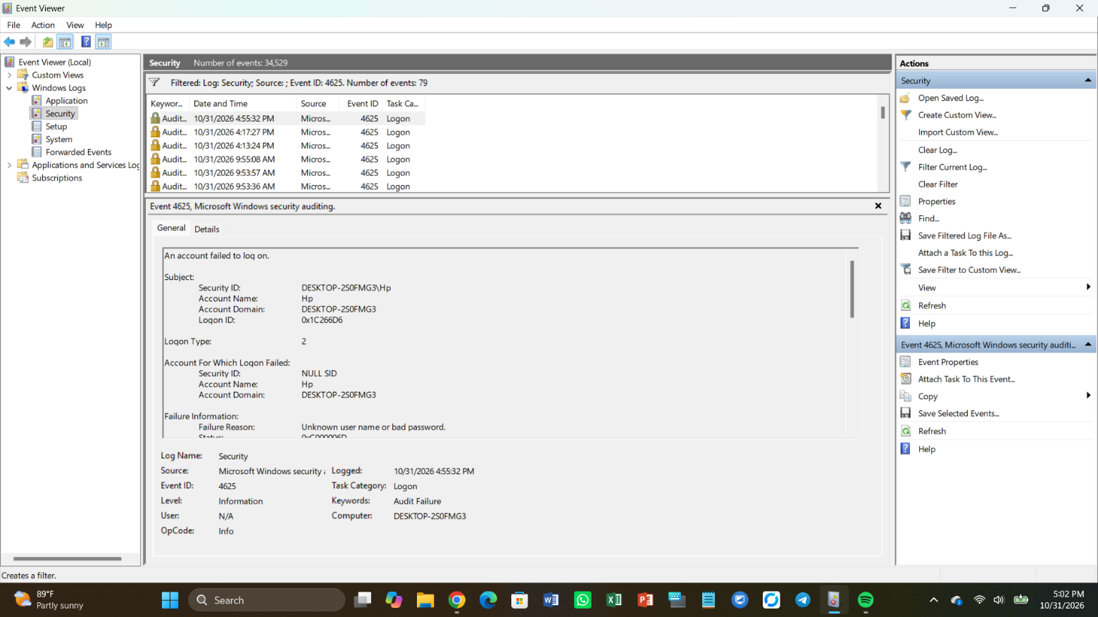

  - Screenshot: Event Viewer filtered by Event ID 1102 (if any exist)


